**Exercise 10.7: Problem 2**

**(a).**

If we use complete linkage, first we fuse clusters 1 and 2 at height 0.3. Then, since 0.45 is the lowest dissimilarity, cluster 3 and 4 will be fused at height 0.45. Then two cluster will be fused at height 0.8.

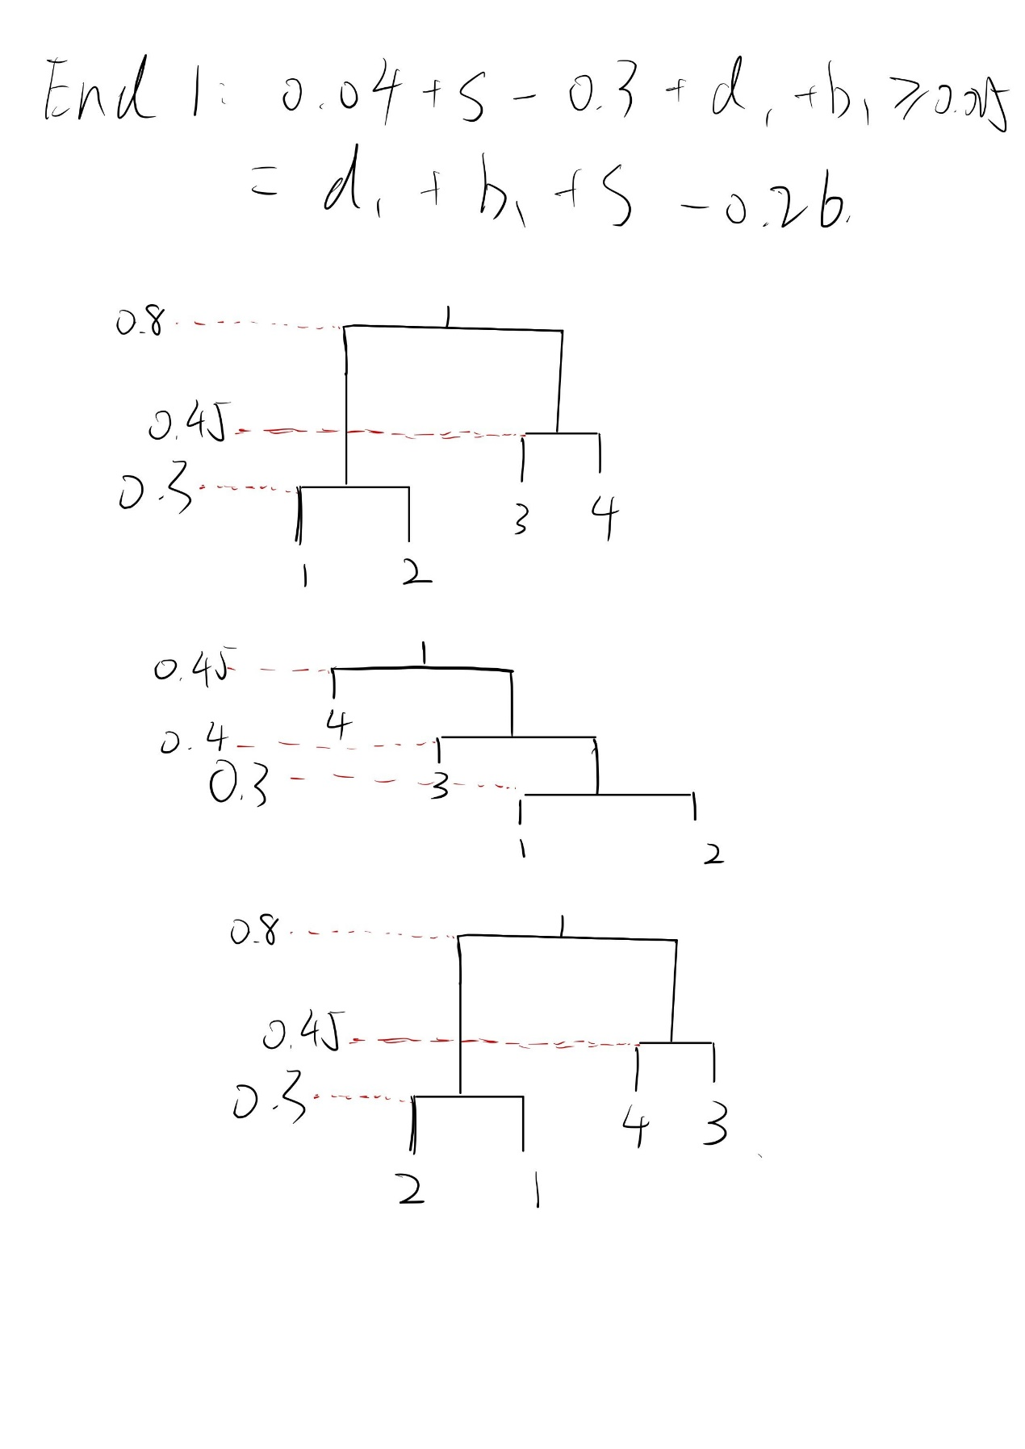

**(b).**

If we use single linkage, first we fuse clusters 1 and 2 at height 0.3. Then, since 0.4 is the lowest dissimilarity, we fuse this cluster and 3. Then, we fuse 4.



**(c).**

Cluster1: 1 and 2.

Cluster2: 3 and 4.

**(d).**

Cluster1: 1, 2 and 3.

Cluster2: 4.

**(e).**

